

**Electric Machine Project Report**

**Project Title: Speed Control of DC-Motor**

2022

**GROUP MEMBERS**



# SYED ZULFIQAR ALI…………………FA20-EEE-059

SYED HASNAT ALI……………………FA20-EEE-058 UMER SALEEM…………………………FA20-EEE-047

# **LAB Engineer**

## SHAHID KHAN

**Subject Teacher**

DR. CH ARSHAD MEHMOOD

**DEPARTMENT OF ELECTRICAL AND COMPUTER ENGINEERING**

**ABSTRACT:**

In Industry DC motor is widely uses for speed control and load characteristics, it’s easy controllability provide effective and precise output. So, application of DC motor is large for commercial purpose. Speed control of DC motor is very crucial in application where required speed is precision and correcting signal representing and to operate motor at constant speed, so we used PWM method which are fulfil all requirements to speed control of DC motor. There are different techniques available for the speed control of DC motors. The phase control method is widely adopted in which ac to dc converters are used to supply the dc motors, but has certain limitations mainly it generates harmonics on the power line and it also has poor p.f. when operated at lower speeds. The second method is pwm technique, which has got better advantages over the phase control. In order to have better open loop speed control as demand varies frequently like in traction system and many operations in industry must be control manually, PWM is most efficient and Page is cheap speed control method for dc drives. By varying resistor pot only, we can control the speed of motor states that simple and easy method.

**INTRODUCTION:**

In this project, I will show How Speed Control of DC Motor can be implemented using aurdino and Pulse Width Modulation (PWM). Most of the industrial process requires to be run on the certain parameters where speed of the drive is concerned. The electric drive systems used in many industrial applications require higher performance, reliability, variable speed due to its ease of controllability. The speed control of DC motor is important in applications where precision and protection are of essence. Purpose of a motor speed controller is to take a signal representing the required speed and to drive a motor at that speed. In this project controller presented uses the pulse width modulation (PWM) technique for speed control of DC motor. We use DC Motors in many systems in our day to day life. For example, CPU fans, fume extinguishers, toy cars etc. are all DC Motors which are operated by DC power supply. Most of the times we will have to adjust the speed of the motors as per our requirement. A CPU Fan for example, must be operated at high speed when the CPU is preforming heavy tasks like games or video editing. But for normal usage like editing documents, the speed of the fan can be reduced. Although some systems have an automatic adjustment system for fan speed, not all systems possess this functionality. So, we will have to adjust the speed of the DC Motor ourselves occasionally

**DC Motor:**

A DC motor is an electric motor that runs on direct current power.It is a device that converts electrical energy to mechanical energy. It works on the fact that a current-carrying conductor placed in a magnetic field experiences a force that causes it to rotate with respect to its original position. Practical DC Motor consists of field windings to provide the magnetic flux and armature which acts as the conductor.The input of a brushless DC motor is current/voltage and its output is torque.DC motor basically consists of two main parts. The rotating part is called the rotor and the stationary part is also called the stator. The rotor rotates with respect to the stator.

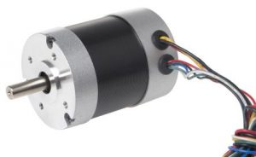

***Brushless DC Motor***

**Figure 1.1**

**Construction of DC Motor**

The construction of the DC motor is shown below. It is very important to know its design before knowing it’s working. The essential parts of this motor include armature as well as stator.The armature coil is the rotating part whereas the stationary part is the stator. In this, the armature coil is connected toward the DC supply which includes the brushes as well as the commutators. The main function of the commutator is to convert the AC to DC which is induced in the armature. The flow of current can be supplied by using the brush from the motor’s rotary part toward the inactive outside load. The arrangement of the armature can be done in between the two poles of the electromagnet or permanent.

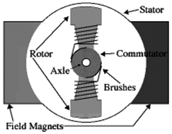

**Figure 1.2**

**DC Motor Parts**

Stator

A stationary part like a stator is one of the parts in DC motor parts which includes the field windings. The main function of this is to get the supply.

1. **Rotor**

The rotor is the dynamic part of the motor that is used to create the mechanical revolutions of the unit.

1. **Brushes**

Brushes using a commutator mainly work as a bridge to fix the stationary electrical circuit toward the rotor.

1. **Commutator**

It is a split ring that is designed with copper segments. It is also one of the most essential parts of dc motor.

1. **Field Windings**

These windings are made with field coils which are known as copper wires. These windings round approximately the slots carried through the pole shoes.

1. **Armature Windings**

The construction of these windings in the DC motor is two types like Lap & Wave.

**INTRODUCTION TO SPEED CONTROL:**

Speed control means intentional change of drive speed to a value required for performing the specific work process. This concept of speed control or adjustment should not be taken to include the natural change in speed which occurs due to change in the load on the shaft. Any given piece of industrial equipment may have its speed change or Adjusted mechanically by means of stepped pulleys, sets of change gears, variable speed friction clutch mechanism and other mechanical devices. Historically it is proved to be the first step in transition from nonadjustable speed to adjustable speed drive. The electrical speed control has many economical as well as engineering advantages over mechanical speed control The nature of the speed control requirement for an industrial drive depends upon its type. Some drives may require continues variation of speed for the whole of the range from zero to full speed or over a portion of this range, while the others may require two or more fixed speeds

**SPEED CONTROL METHOD OF DC MOTOR:**

**1. Flux Control Method**

In the flux control method, a rheostat (a type of variable resistor) is connected in series with the field windings. The purpose of this component is to increase the series resistance in the windings which will reduce the flux, consequently increasing the motor’s speed.

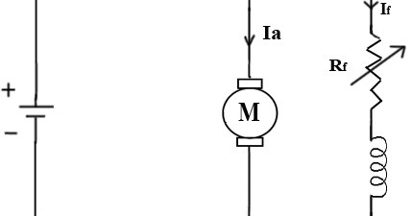

**Figure 1.3**

**2. Voltage Regulation Method**

The variable regulation method is typically used in shunt dc motors. There are, again, two ways to achieve voltage regulation control:

• Connecting the shunt field to a fixed exciting voltage while supplying the armature with different voltages (aka multiple voltage control)

• Varying the voltage supplied to the armature ( the Ward Leonard method)

**Ward-Leonard System:**

ward leonard system speed control of dc motor. This system is used where very sensitive speed control of motor is required (e.g electric excavators, elevators etc.). The arrangement of this system is as shown in the figure at right.

M2 is the motor to which speed control is required.

M1 may be any AC motor or DC motor with constant speed.

G is a generator directly coupled to M1.

In this method, the output from generator G is fed to the armature of the motor M2 whose speed is to be controlled. The output voltage of generator G can be varied from zero to its maximum value by means of its field regulator and, hence, the armature voltage of the motor M2 is varied very smoothly. Hence, very smooth speed control of the dc motor can be obtained by this method.

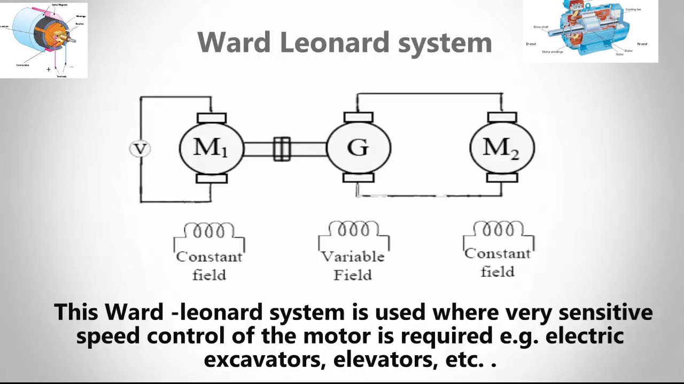

**Figure 1.4**

**3. Armature Resistance Control Method**

The armature resistance control is based on the principle that the speed of the motor is directly proportional to the back EMF. So, if the supply voltage and the armature resistance are kept at a constant value, the speed of the motor will be directly proportional to the armature current.

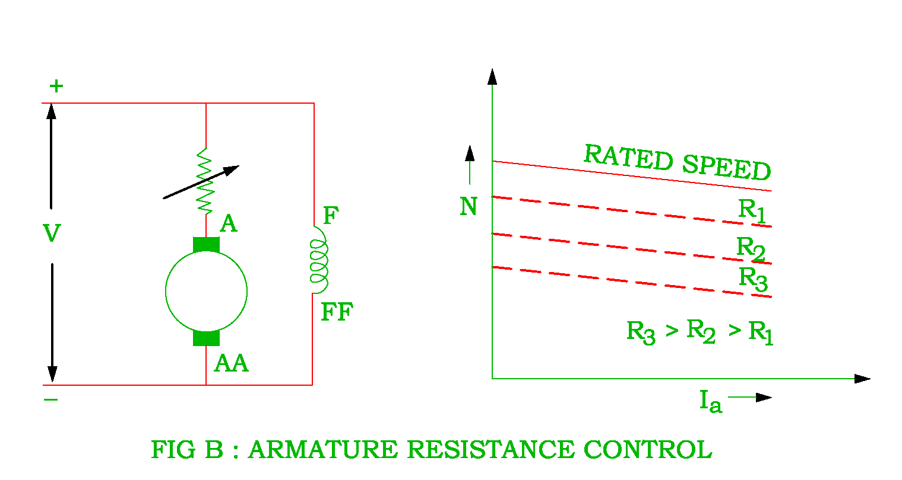

**Figure 1.5**

**BLOCK DIAGRAM:**

Power supply

Display 16*2

Control unit Arduino Uno

DC Motor

s

Motor Driver

L2983D

**CIRCUIT DIAGRAM:**

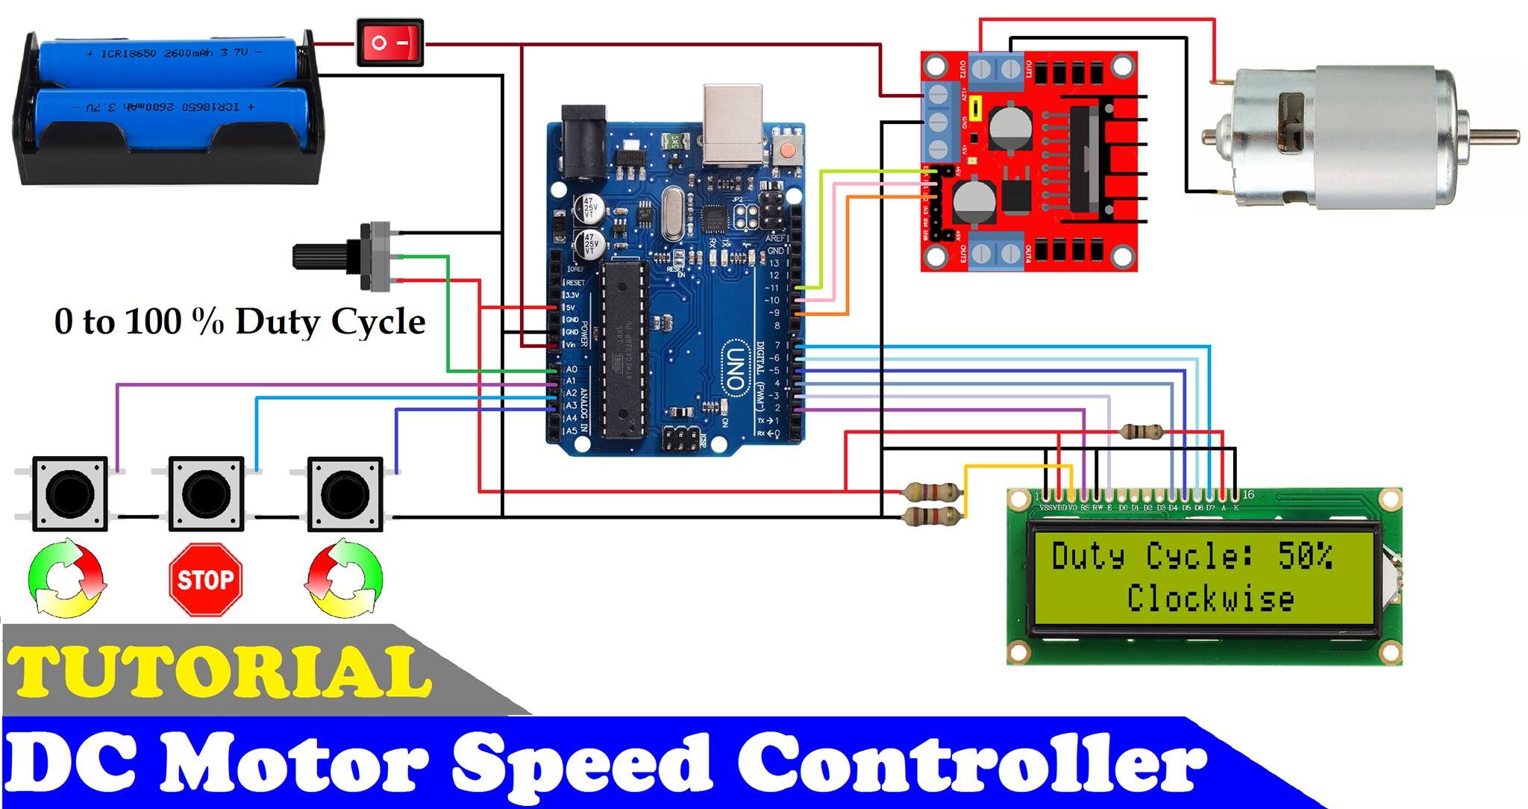

**Figure 1.6**

**PROTEUS SIMULATION**

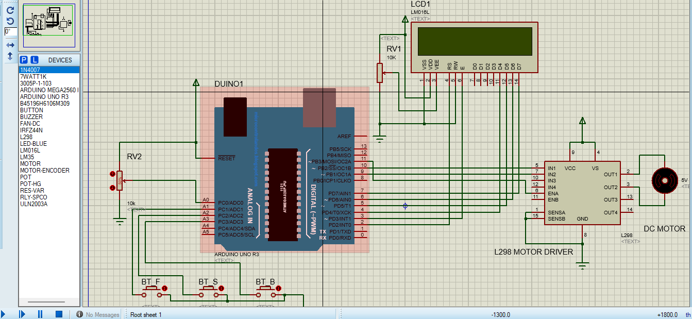

**Figure 1.7**

**OPEN LOOP CONTROL OF DC-MOTOR**

A Control System which doesn’t have any feedback connected to it is called as Open Loop System. These types of systems don’t depend upon its output i.e., in open loop systems, output is not used as a control variable for the system and it has no effect on the input.

Open loop systems are one way signal flow systems. As these systems doesn’t contain any feedback i.e., the output is not fed back to the input, these are also known as Non-Feedback Systems.

The following image shows a simple block diagram of an Open Loop System.

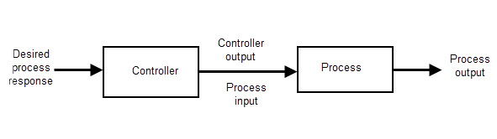

**Figure 1.8**

n an open loop system, the output can be adjusted / varied by varying the input but the output has no effect on the input. The output of the open loop system can be determined only by its present state input. If the output is affected due to some external noise / disturbance, the open loop system cannot correct it.

Also, there is no chance to correct the transition errors in open loop systems so there is more chance to occur errors.

Open Loop System Applications

We use open loop control systems in many applications of our day-to-day lives. Some of the popular systems, which are designed based on the concept of open loop control systems, are mentioned below:

* Washing Machine
* Electric Bulb
* Electric Hand Drier
* Time based Bread Toaster
* Automatic Water Faucet
* TV Remote Control
* Electric Clothes Drier
* Shades or Blinds on a window
* Stepper Motor or Servo Motor
* Inkjet Printers
* Door Lock System
* Traffic Control System

**Advantages of Open Loop Control System**

The main advantages of the open loop control system are listed below:

* Open Loop Control Systems are very simple and easy to design.
* These are considerably cheaper than other types of control systems.
* Maintenance of an open loop control system is very simple.
* Generally, open loop systems are stable up to some extent.
* These types of systems are easy to construct and are convenient to use.

**Disadvantages of Open Loop control System**

The disadvantages of open loop system are:

* The bandwidth of open loop control system is less.
* The non-feedback system doesn’t facilitate the process of automation.
* Open loop systems are inaccurate in nature and also unreliable.
* If their output is affected by some external disturbances, there is no way to correct them automatically as these are non-feedback systems.

**COMPONENTS REQUIRED:**

1. Solderless Breadboard
2. Arduino Uno
3. 16×2 LCD Display
4. Push Button x 3
5. L298 Motor Driver
6. 12v DC Motor
7. 10k Variable Resistor
8. 100R Resistor
9. 4.7k Resistor
10. 1k Resistor
11. Male to Male Jumper Wires
12. Male to Female Jumper Wires
13. On/Off Switch
14. 18650 Battery Holder – 2 Cell
15. 18650 Battery Cell 3.7V x 2

Off Switch, 1865

**REFRENCE :**

[**https://github.com/ZA5starCoder/Automatic-Certificate-Generator**](https://github.com/ZA5starCoder/Automatic-Certificate-Generator)